识别准确率最低的和类别平均分最低30类中，总stroke length较长的样本

1. Dragon

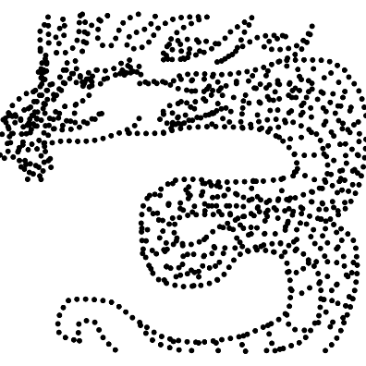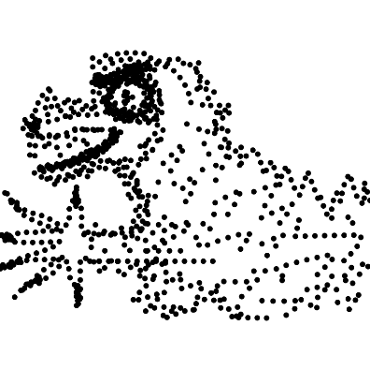

Pred: mermaid, owl, hedgehog, dragon, sponge bob

Pred: feather, comb, parrot, ashtray, leaf

1. Panda

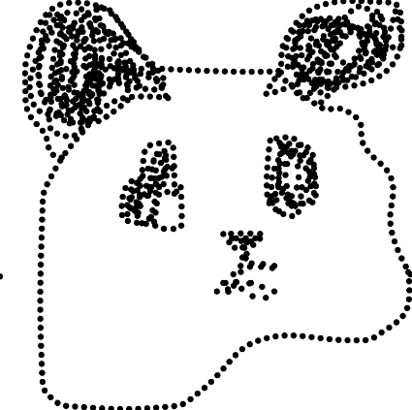

Pred: mermaid, monkey, saxphone, head, face

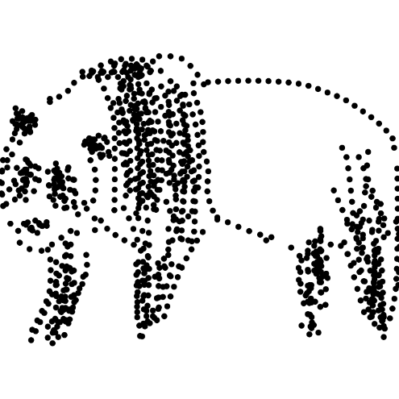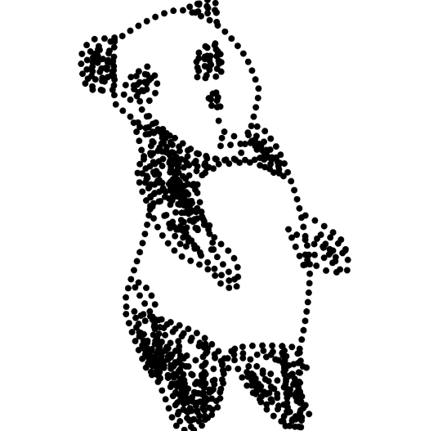

Pred: comb, flower with stem, feather, bush, cow

Pred: screwdriver, rifle, comb, guitar, feather

1. Tiger

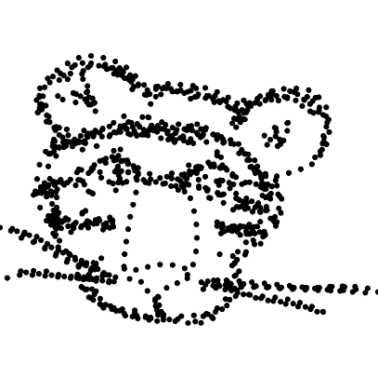

Pred: pineapple, brain, bush, tooth, lobster

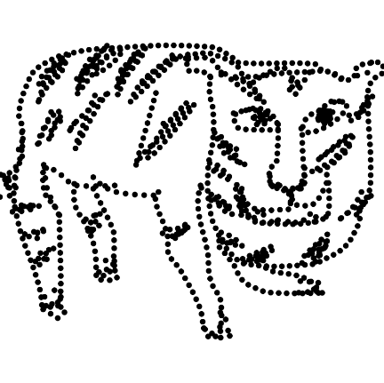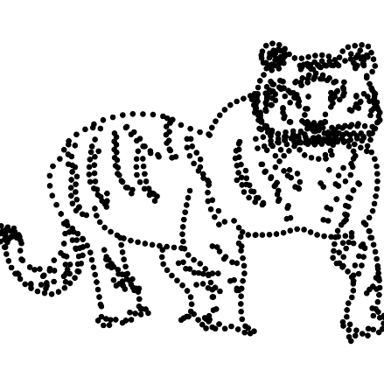

Pred: comb, tiger, bush, flower with stem, train

Pred: flower with stem, grapes, feather, comb, lobster

1. Bulldozer

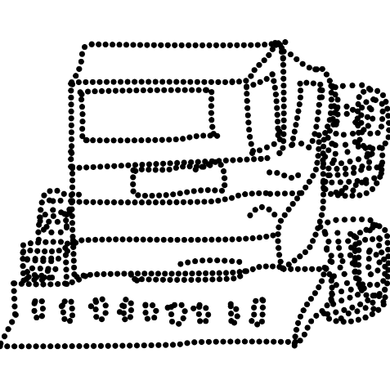

Pred: micorscoppe, crane, santa claus, tractor, chandelier

1. Meimaid

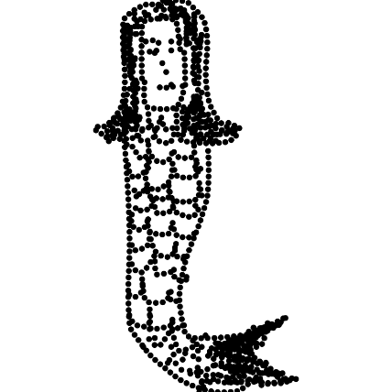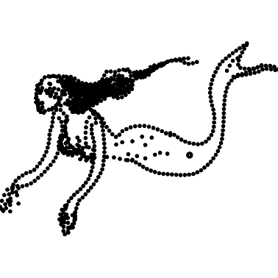

Pred: flower with stem, comb, feather, toothbrush, train

Pred: mermaid, parking meter, crocodile, persong walking, microphone